Easy Read Information Pack for people with Learning Disabilities living in and around Crediton

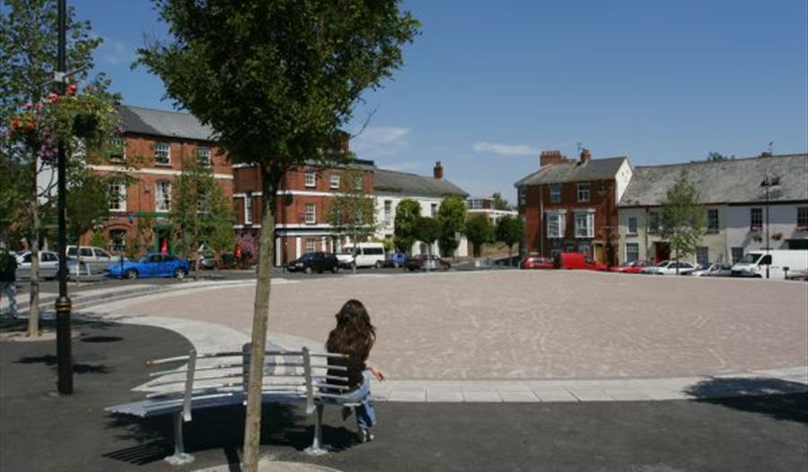

Introduction
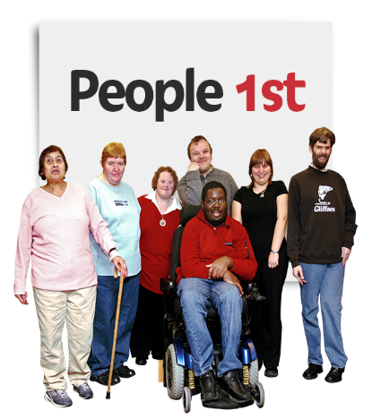  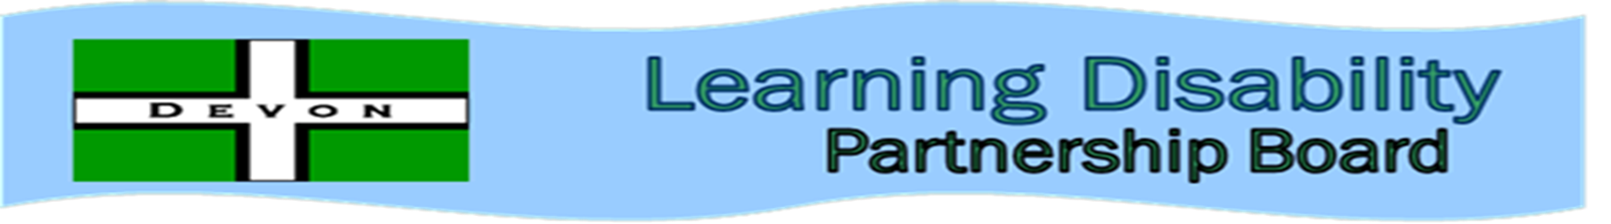 | This Easy Read Information Pact has been created by Devon People First with the help of People with learning disabilities in Crediton.  Devon People First is a peer advocacy project that supports people with learning disabilities to speak up for themselves.  We are working with the Learning Disability Partnership Board on a new project called the Citizenship project.
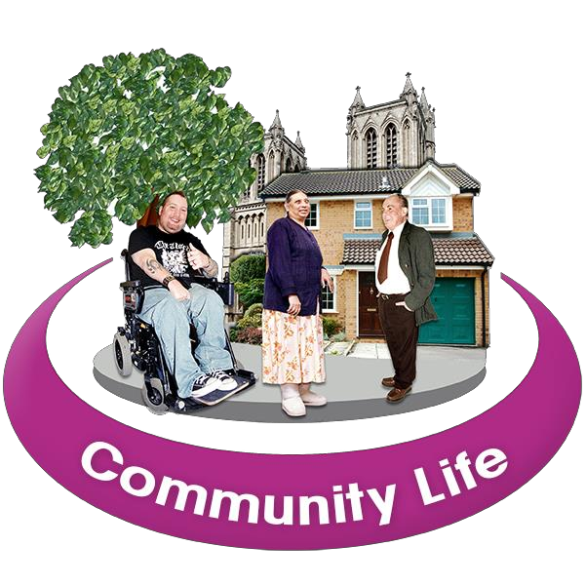  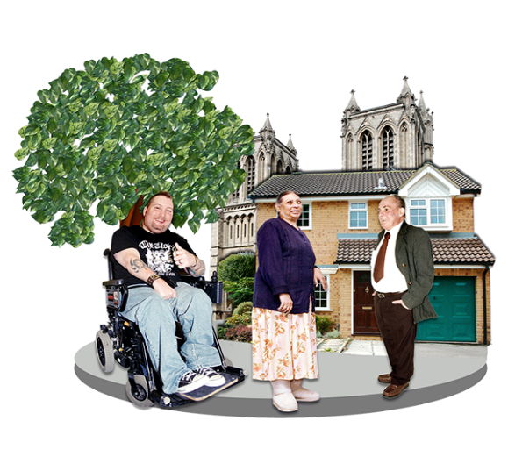 | The Citizenship project is about working with people in local communities so that people with learning disabilities are able to access their communities and have the same rights and opportunities as everyone else.  Being able to access community life is really important to their long term independence and wellbeing and reduces the need for statutory services.

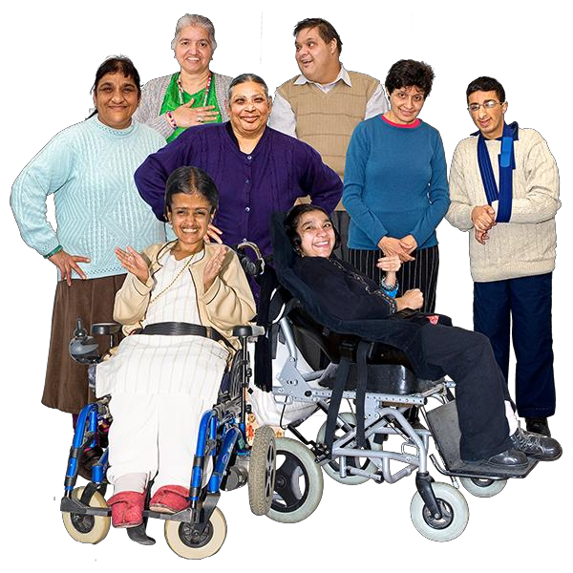 | People want to Be able to make friends and socialise, have real friends and relationships, Have a Job, Be able to use services in their community like going swimming at the leisure centre, join keep fit or dance classes, All the things that are accessible to everyone else.  This information pack will help empower people with learning disabilities in Crediton to enact their rights and become active citizens.
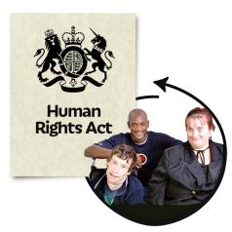  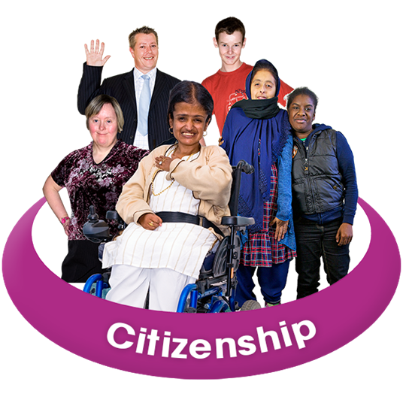 | We have included in this easy read information pack a section on what Citizenship is and why it is important.  We have also included a section on Equality and Human Rights.  These are your rights.

